**Supplemental Information**

Boxplots:

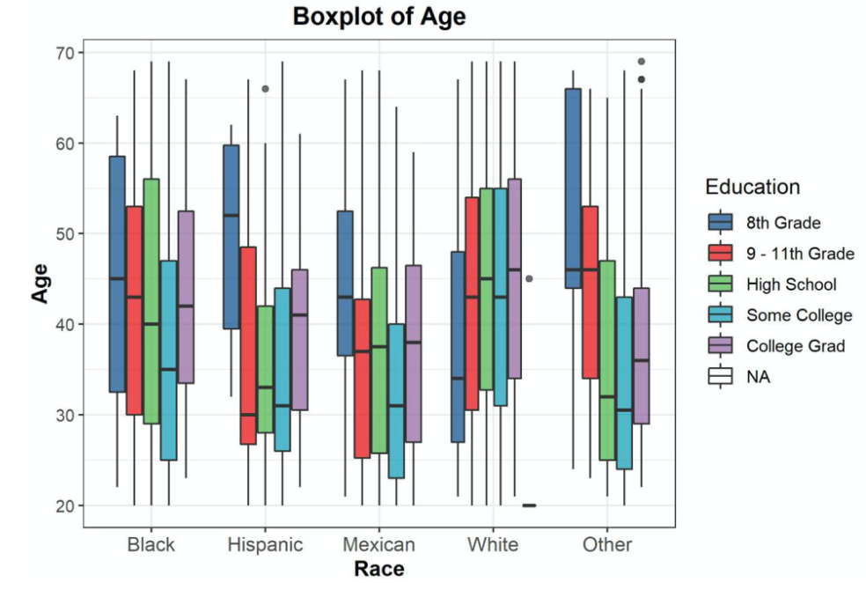

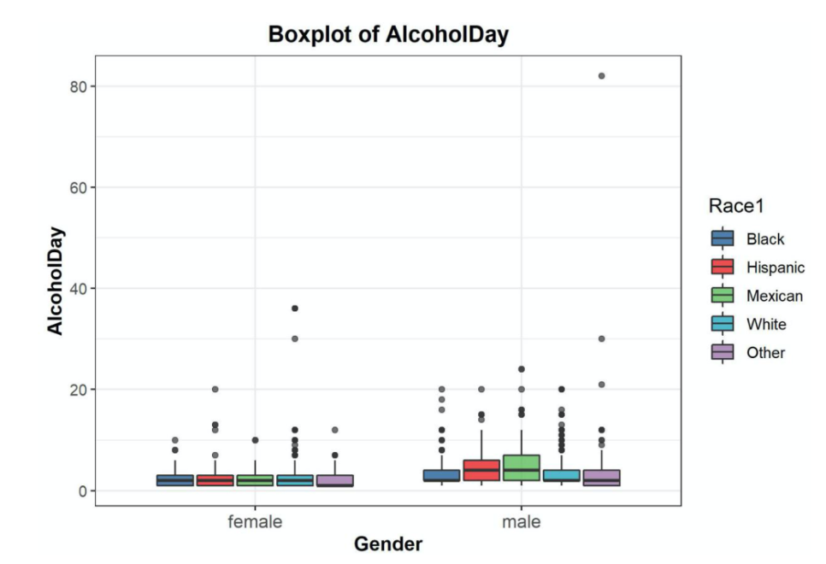

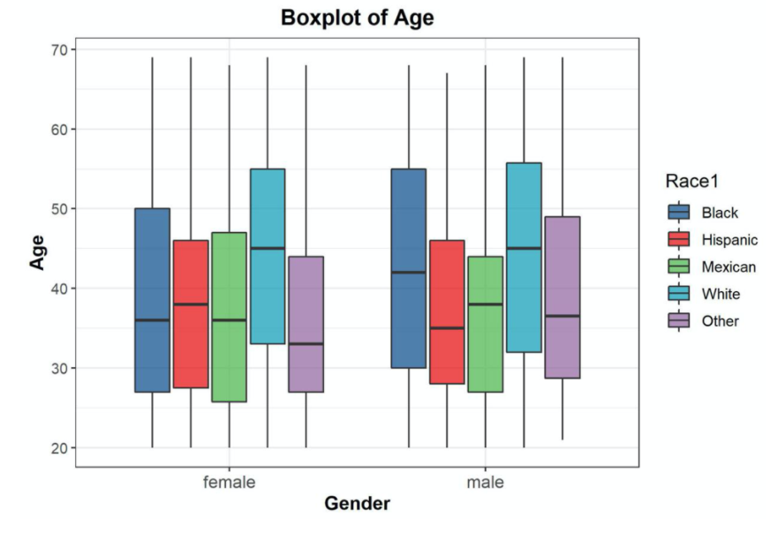

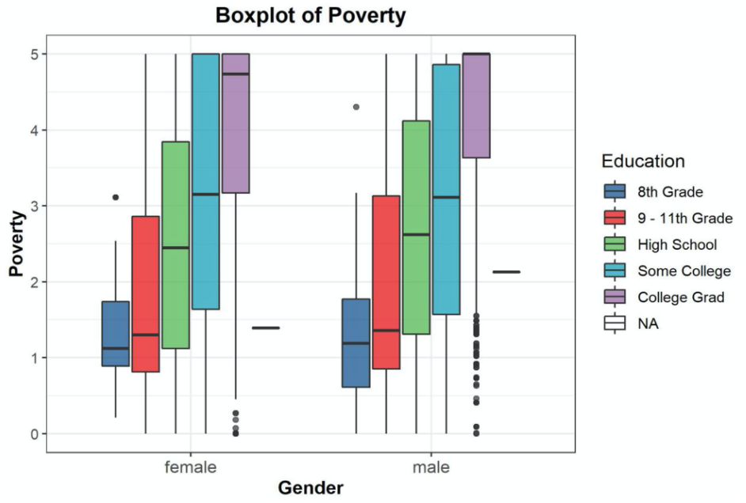

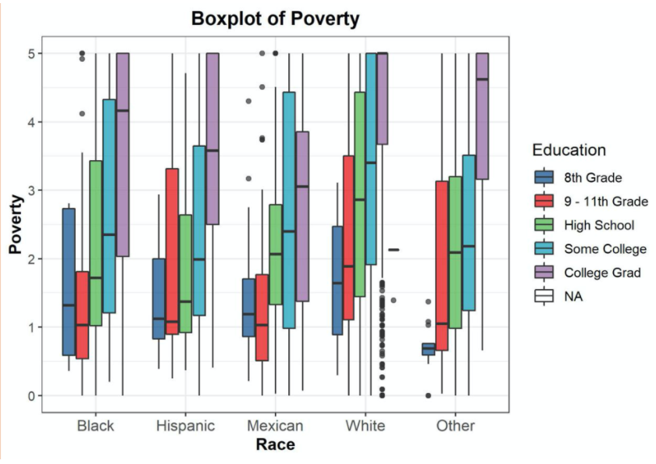

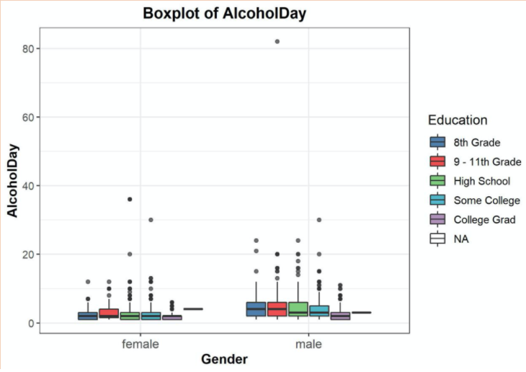

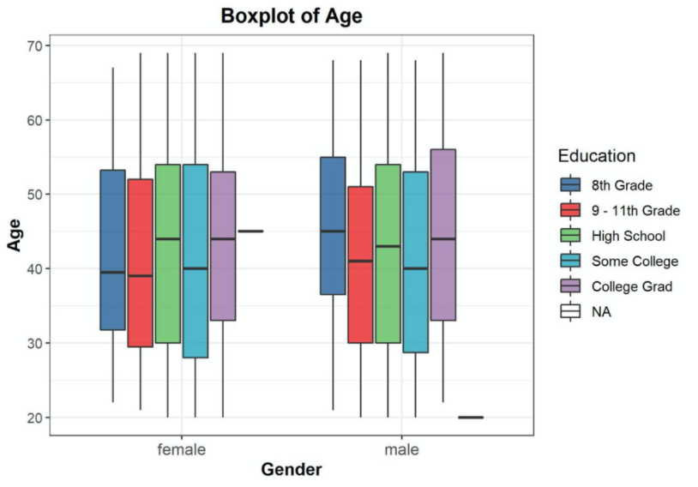

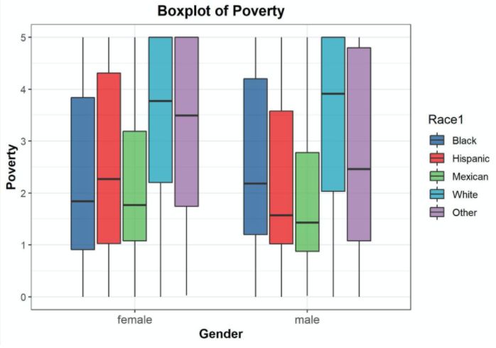

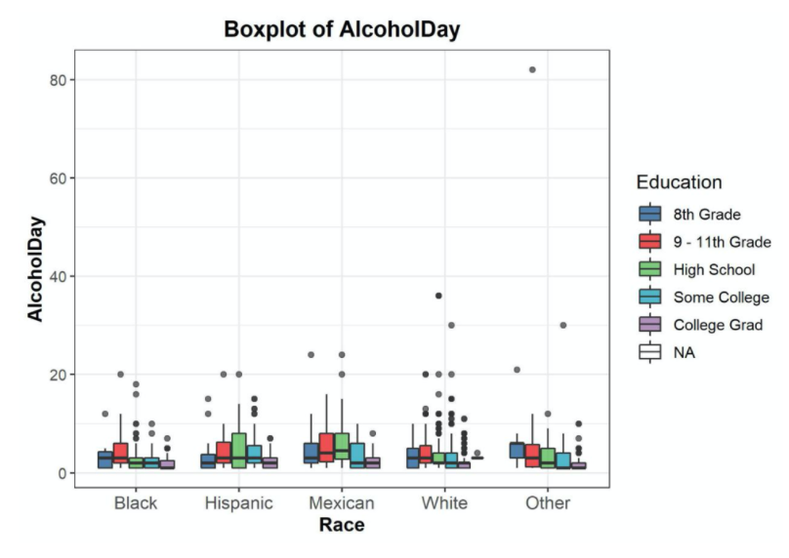

Correlation Plots:

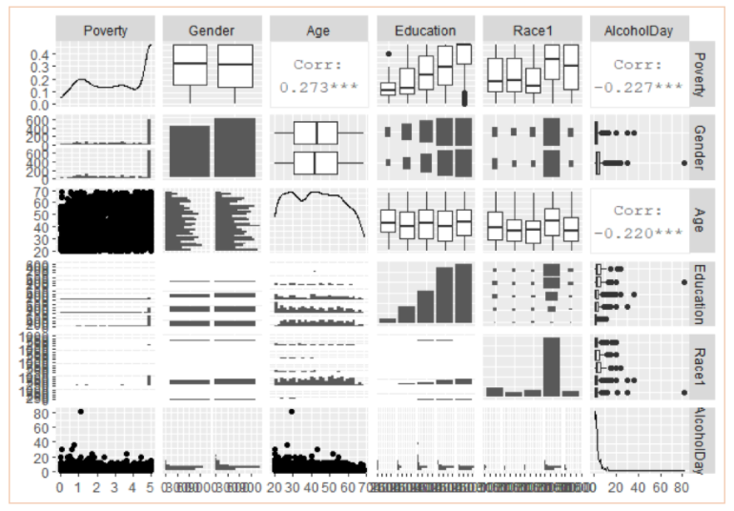

Table 1 (Covariates Table):

|  |  |  |
| --- | --- | --- |
| Covariate | What it Includes | Definition |
|  | Categorical variable of *AlcoholDay*; with median of 2 and standard deviation of 3.23637 with four total categories - with 1st category being half a standard deviation away from the median and then the 2nd category being one standard deviation away from the median and so on | Average number of drinks consumed on days that participant drank alcoholic beverages; reported for participants 18 years or older |
|  | All ages with 80 years old being reported as the highest age since anyone over 80 years old were recorded as 80 years old | Age in years at screening of study participant |
|  | Mexican, Hispanic, White, Black, or Other | Reported race of study participant |
|  | 8thGrade, 9-11thGrade, HighSchool, SomeCollege, CollegeGrad | Educational level of study participant reported for participants 20 years or older |
|  | Dichotomized *Gender* variable such that a female subject would be assigned a value of 1 and male a value of 0 | Gender of study participant (male or female) |
|  | Age*Mexican, Age*Hispanic, Age*White, Age*Black, Age*Other | Ages of study participants from their respective race |
|  | Mexican*8thGrade, Mexican*9-11thGrade, Mexican*HighSchool, Mexican*SomeCollege, Mexican*CollegeGrad, Hispanic*8thGrade, Hispanic*9-11thGrade, Hispanic*HighSchool, Hispanic*SomeCollege, Hispanic*CollegeGrad, White*8thGrade, White*9-11thGrade, White*HighSchool, White*SomeCollege, White*CollegeGrad, Black*8thGrade, Black*9-11thGrade, Black*HighSchool, Black*SomeCollege, Black*CollegeGrad, Other*8thGrade, Other*9-11thGrade, Other*HighSchool, Other*SomeCollege, Other*CollegeGrad, | Educational level of study participants for each race |
|  | Mexican*(female=1), Mexican*(female=0), Hispanic*(female=1), Hispanic*(female=0), White*(female=1), White*(female=0), Black*(female=1), Black*(female=0), Other*(female=1), Other*(female=0) | Gender of study participants from each race |

Table 2:

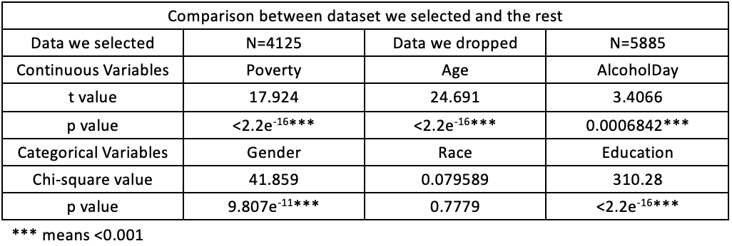

Main Effect Model Summary:

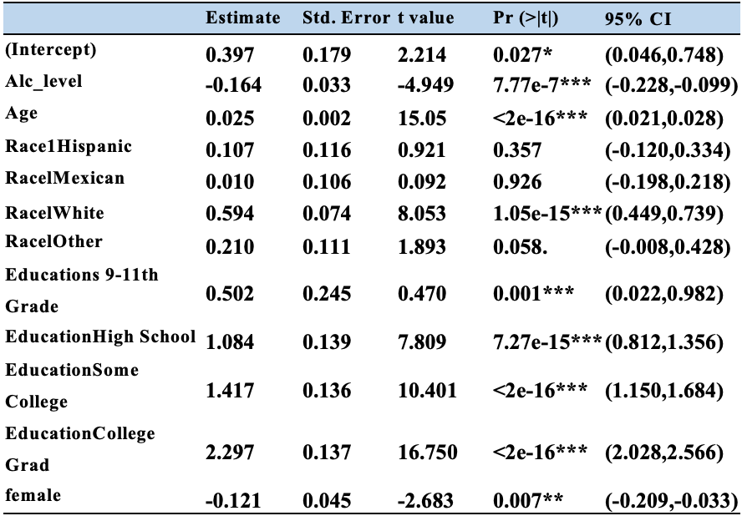

Final Interaction Model Summary:

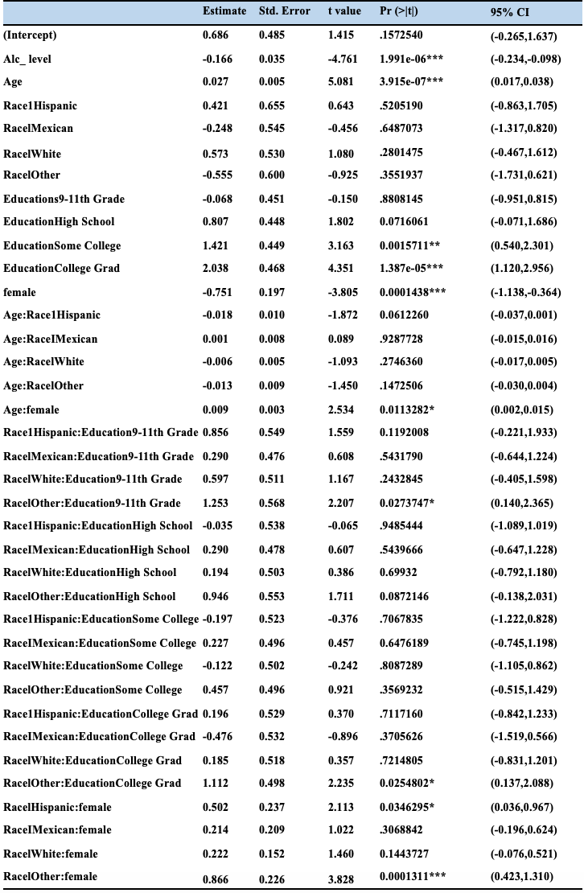

*Alc_level* vs. *Poverty* Scatterplot:

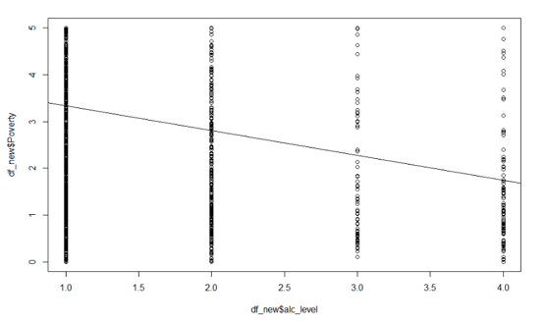

Fitted Values vs. Residuals Plot:

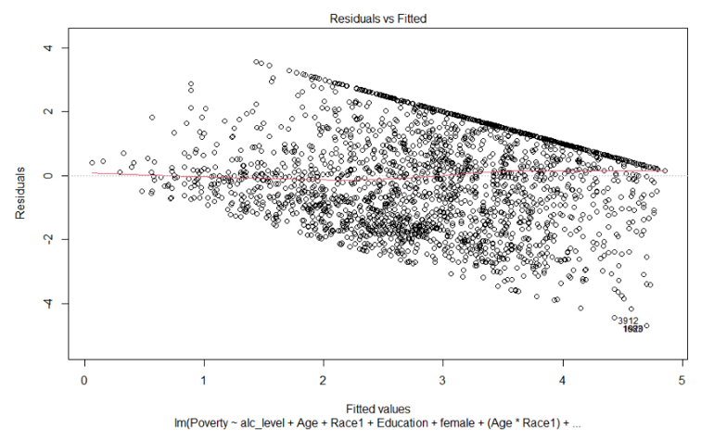

Estimates vs. Std Errors Plot:

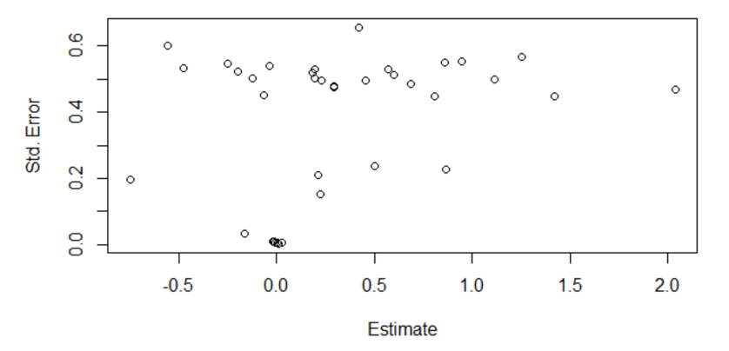

Normal Q-Q Plot:

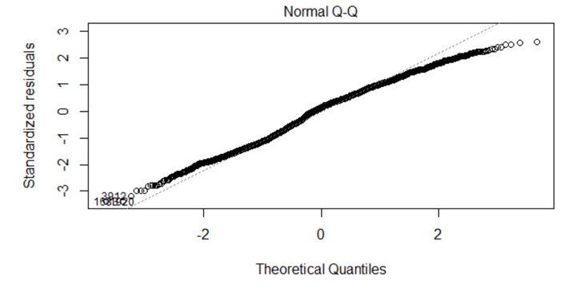

Cook’s Distance Plot:

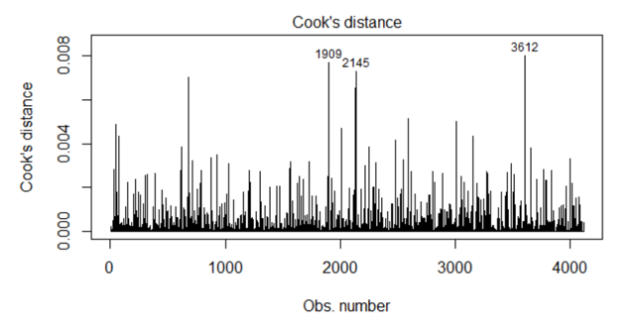

Studentized Residuals Plot:

